**Assignment - Week 1 Day 3**

**Submitted by:**

**23. Sunil Thapa(612810)**

**14. Anish Maharjan (613446)**

**5. Kapil Dangol (613417)**

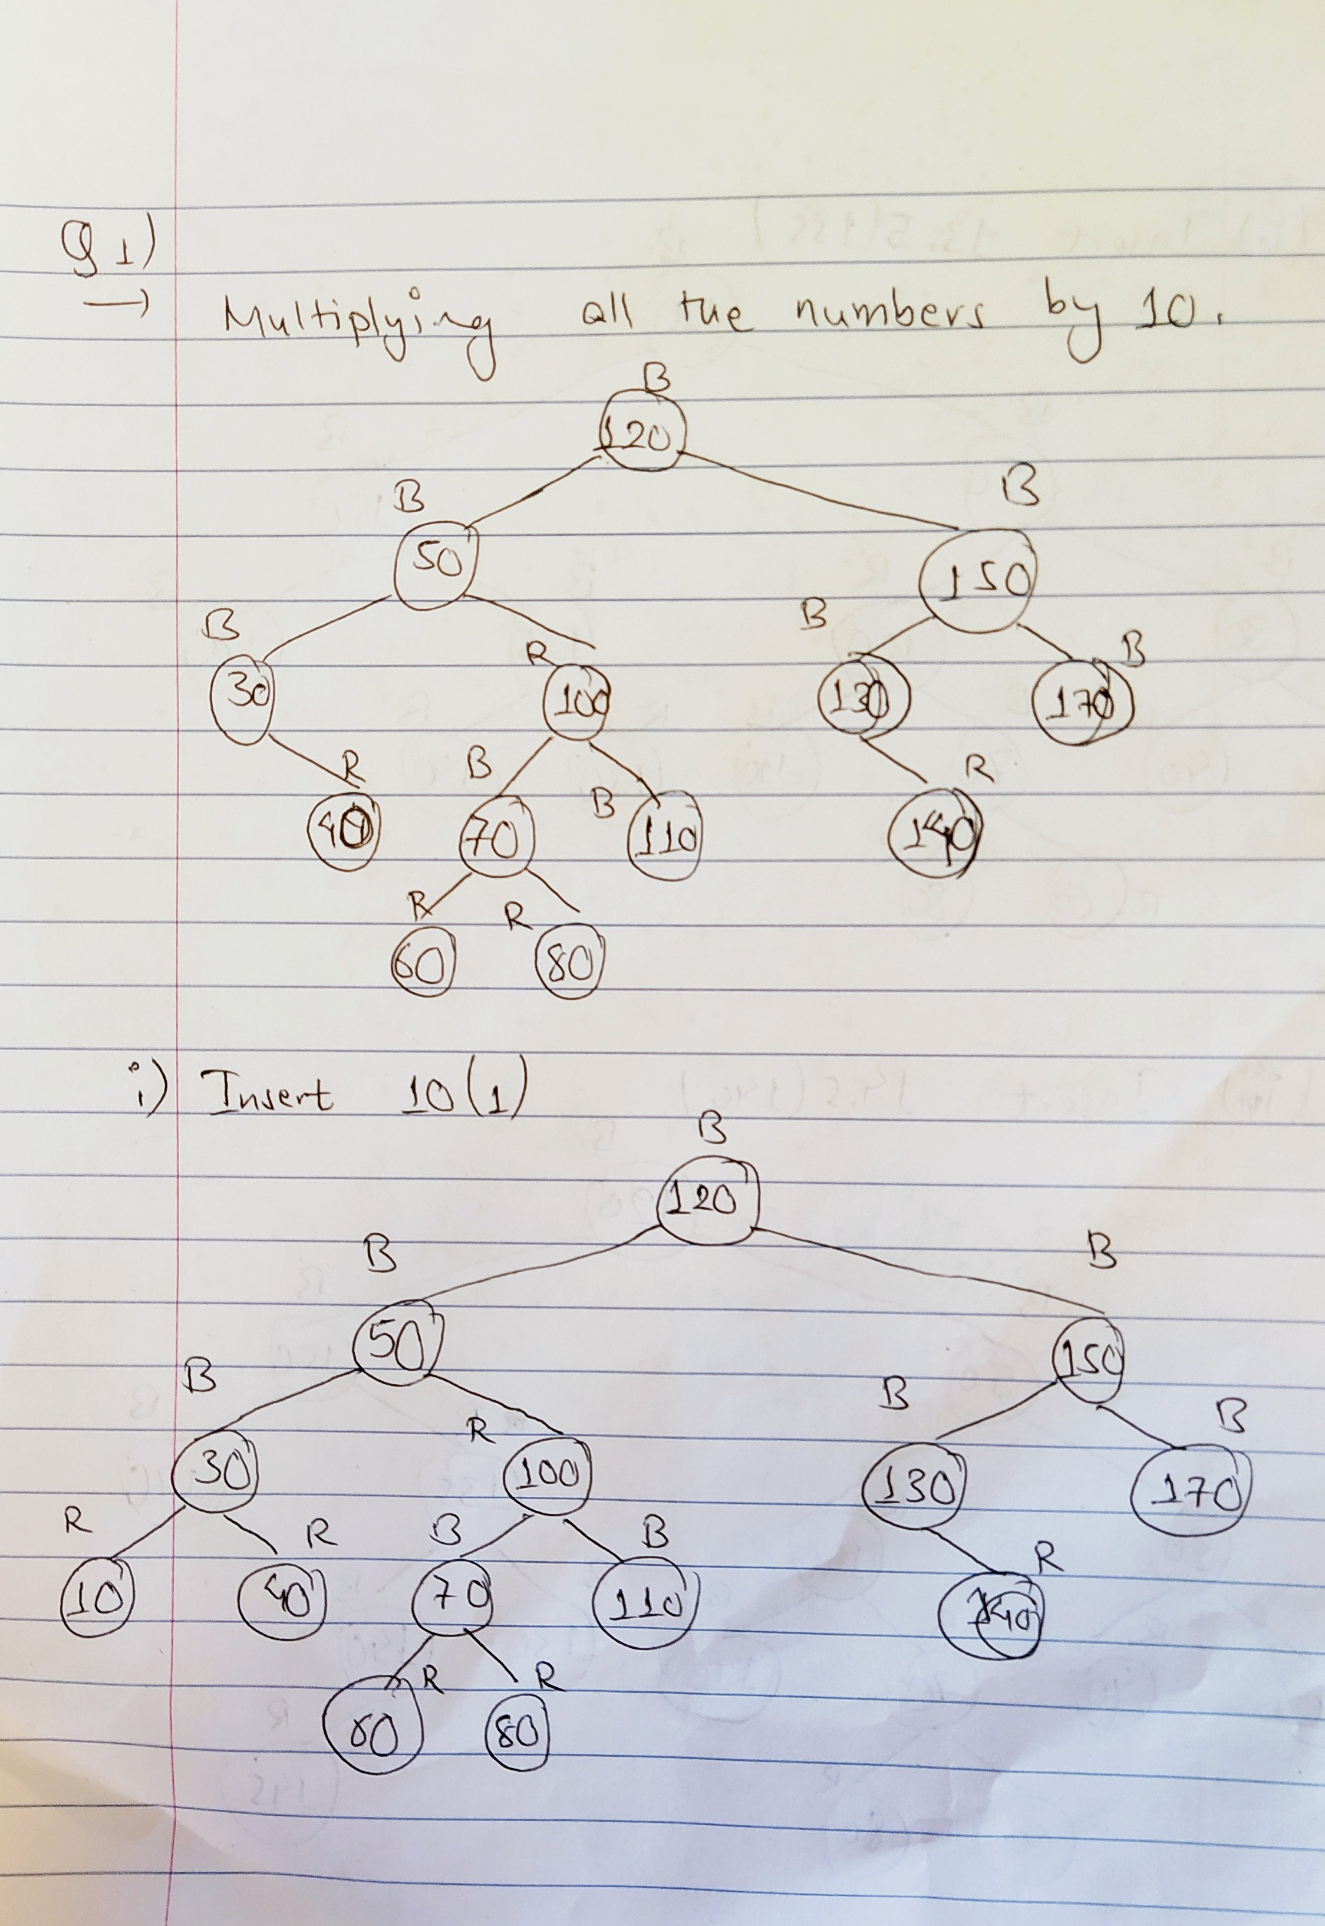Question 1)

→

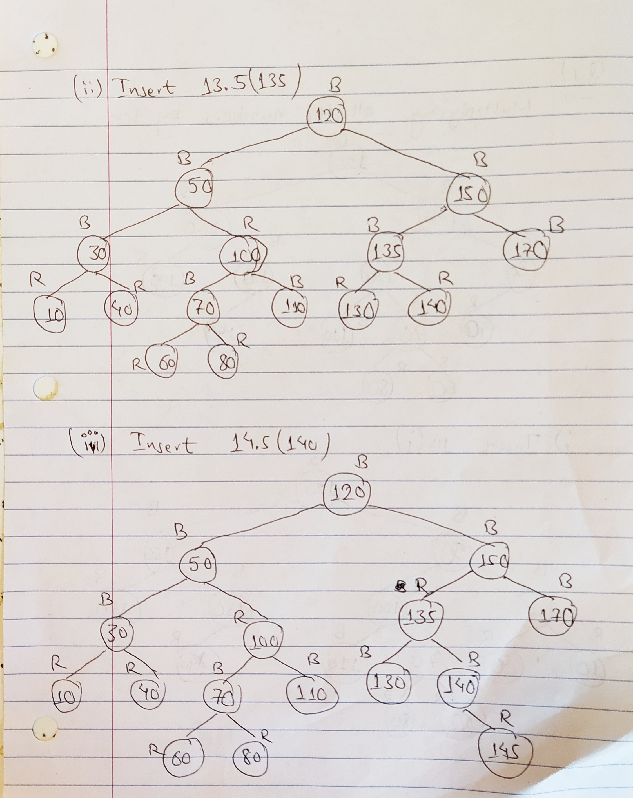

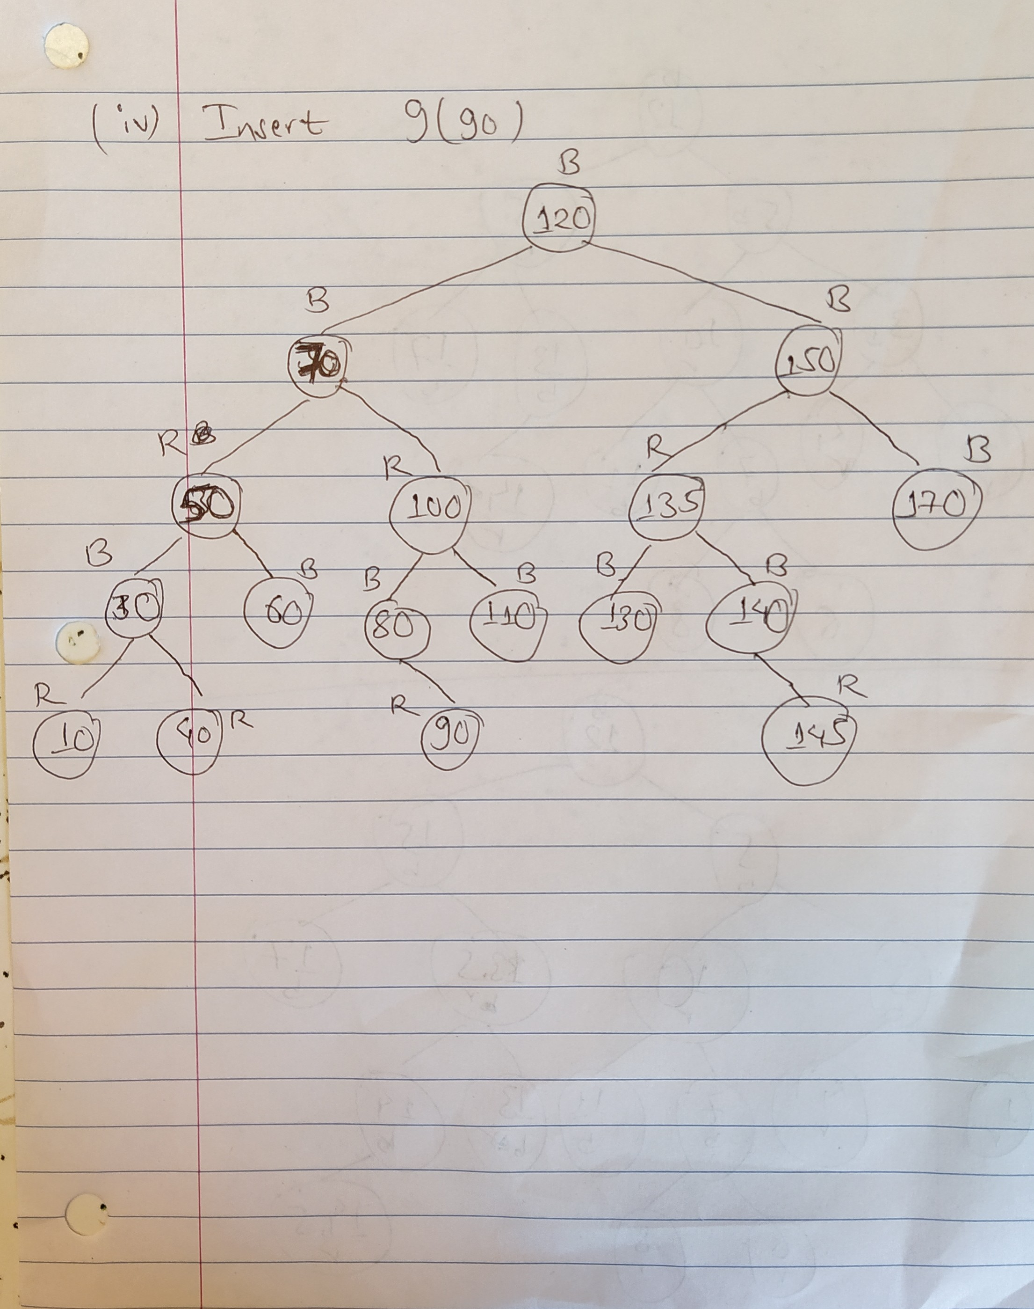

Question 2)

